**Web Page Assignment**

**Abdullah Ashfaq**

**New Batch (evening)**

**Original website:** [**https://procreator.design/**](https://procreator.design/)

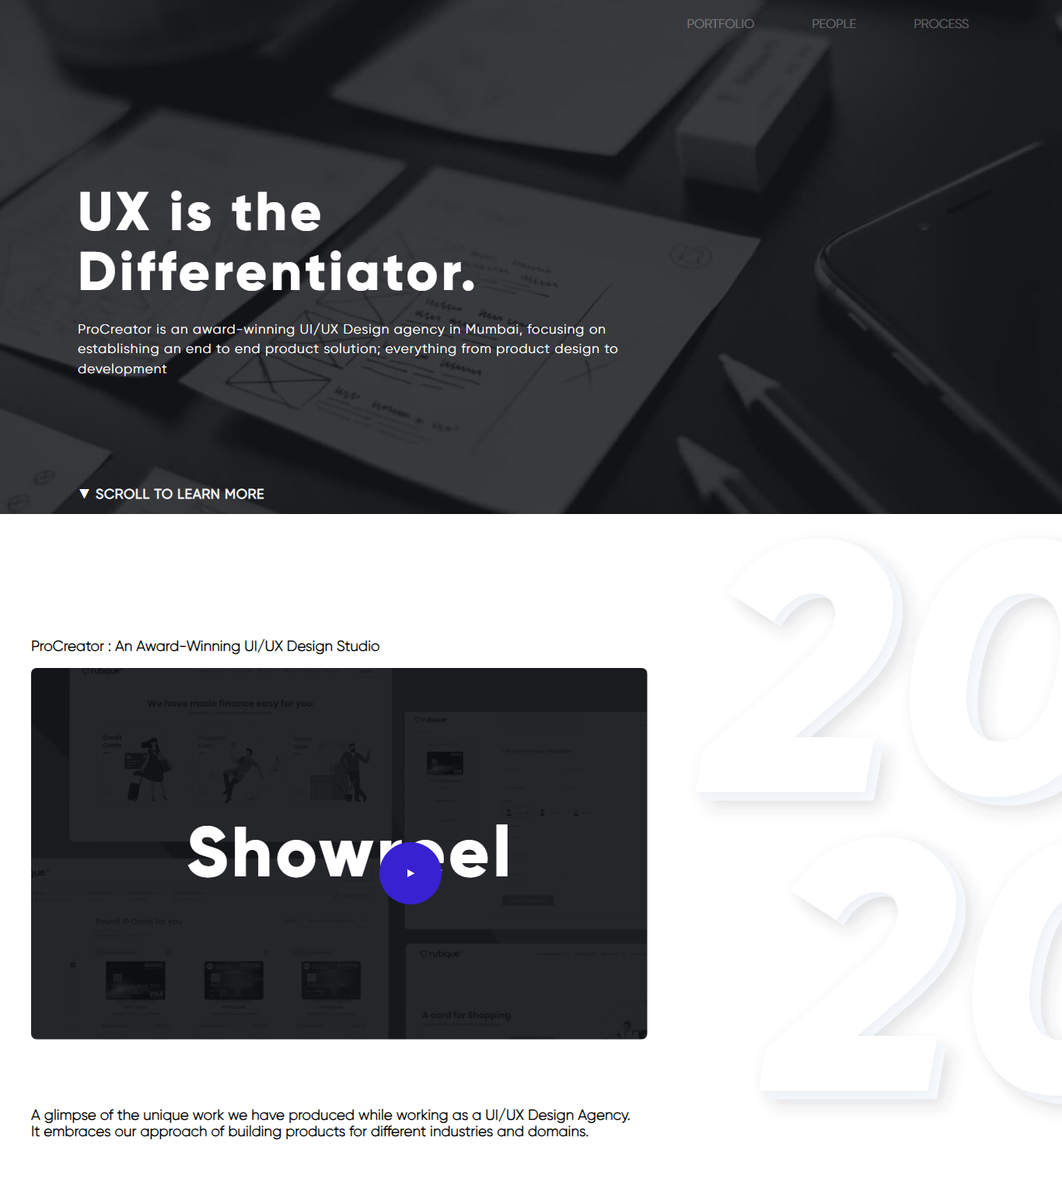

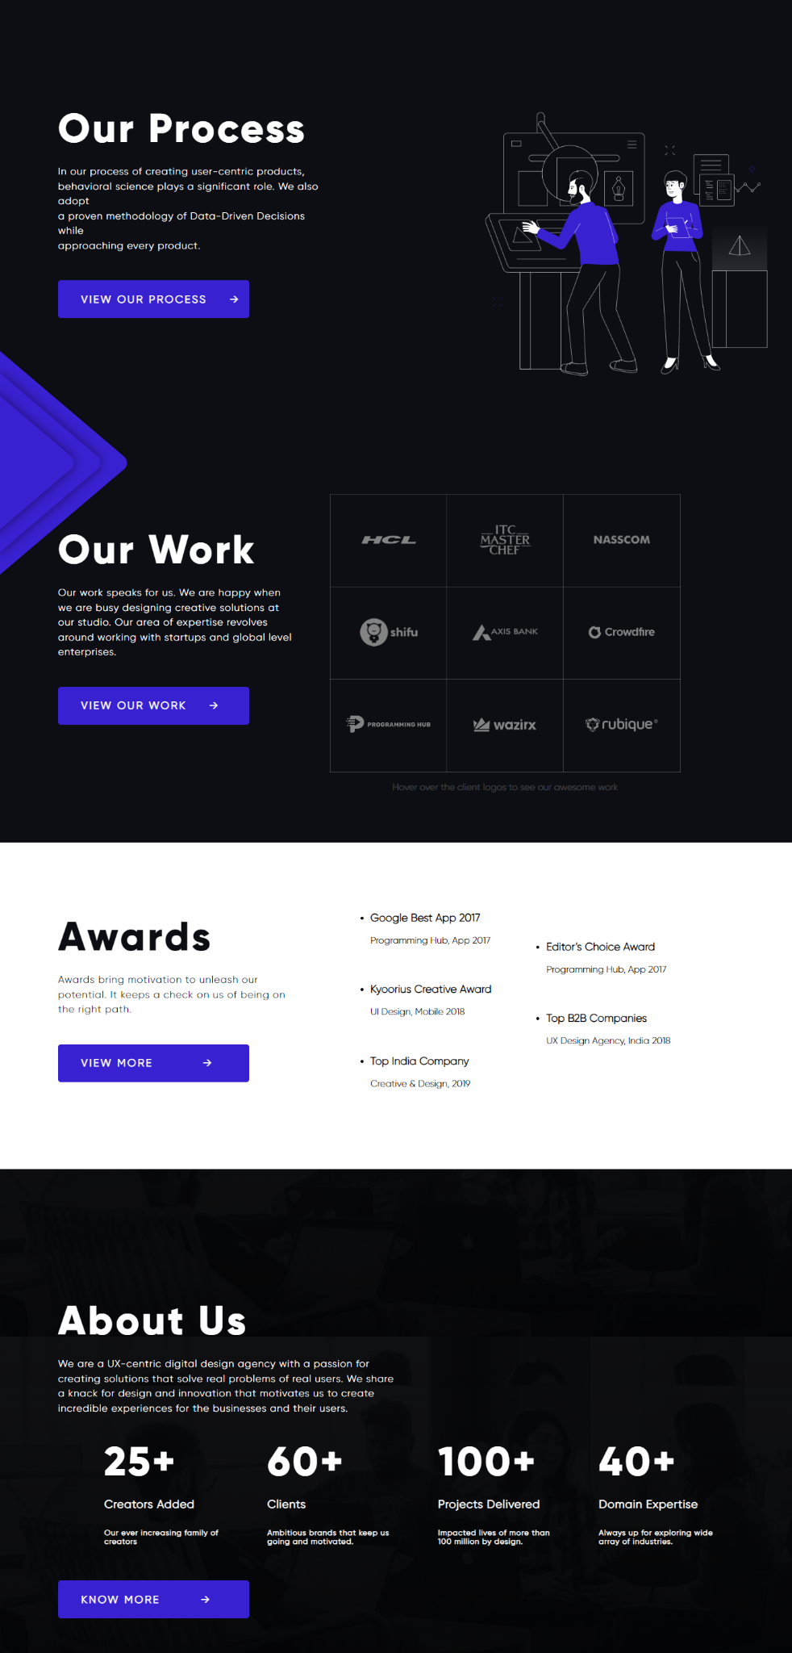

**HTML**

<!DOCTYPE html>

<html lang="en">

<head>

<meta charset="UTF-8">

<meta http-equiv="X-UA-Compatible" content="IE=edge">

<meta name="viewport" content="width=device-width, initial-scale=1.0">

<title>ProCreator</title>

<link rel="stylesheet" href="style.css">

</head>

<body>

<div class="navbar">

<nav>

<ul>

<li class="nav-list">PORTFOLIO</li>

<li class="nav-list">PEOPLE</li>

<li class="nav-list">PROCESS</li>

</ul>

</nav>

<div class="hero">

<div class="head-text">

<h1 class="head">UX is the</h1>

<h1 class="head">Differentiator.</h1>

<p class="top">ProCreator is an award-winning UI/UX Design agency in Mumbai, focusing on <br> establishing an end to end product solution; everything from product design to <br> development</p>

<br><br><br> <br><br><br>

<h3 class="top" id="scroll">▼ SCROLL TO LEARN MORE</h3>

</div>

</div>

</div>

<div class="home-2">

<h3>ProCreator : An Award-Winning UI/UX Design Studio</h3>

<img src="video-thumbnail.png" alt="" class="thumbnail" >

<h2 class="head" id="reel">Showreel <button class="play"> ▶ <a href="https://www.youtube.com/watch?v=Rl7fwMIRp24;autoplay=1"></a> </button></h2>

<h3 id="para">A glimpse of the unique work we have produced while working as a UI/UX Design Agency. <br> It embraces our approach of building products for different industries and domains.</h3>

</div>

<div class="home-3">

<div class="head-text-2">

<h1 class="head">Our Process</h1>

<p class="top">In our process of creating user-centric products, <br> behavioral science plays a significant role. We also adopt <br> a proven methodology of Data-Driven Decisions while <br> approaching every product.</p>

<button class="process-button">VIEW OUR PROCESS &nbsp; &nbsp; →</button>

<img src="speed.svg" alt="" id="speed">

</div>

<div class="process" >

<img src="our-process.svg" alt="" id="process-pic" >

</div>

<div class="home-4" id="home4">

<div class="head-text-3">

<h1 class="head">Our Work</h1>

<p class="top">Our work speaks for us. We are happy when <br> we are busy designing creative solutions at <br> our studio. Our area of expertise revolves <br> around working with startups and global level <br> enterprises.</p>

<button class="process-button" id="process-bt">VIEW OUR WORK &nbsp; &nbsp; →</button>

</div>

<div class="work">

<table>

<tbody>

<tr>

<td> <img src="hcl.png" onmouseover="changebg('1.jpg')" onmouseout="revert()" alt="" class="table-img"></td>

<td><img src="itc-masterchef.png" onmouseover="changebg('2.jpg')" onmouseout="revert()" class="table-img"></td>

<td><img src="nasscom.png" onmouseover="changebg('3.jpg')" onmouseout="revert()" alt="" class="table-img"></td>

</tr>

<tr>

<td><img src="playshifu.png" onmouseover="changebg('4.jpg')" onmouseout="revert()" alt=""class="table-img"></td>

<td><img src="axis-bank.png" onmouseover="changebg('5.jpg')" onmouseout="revert()" alt=""class="table-img"></td>

<td><img src="crowdfire.png" onmouseover="changebg('6.jpg')" onmouseout="revert()" alt=""class="table-img"></td>

</tr>

<tr>

<td><img onmouseover="changebg('7.jpg')" onmouseout="revert()" src="programming-hub.png" alt="" class="table-img"></td>

<td><img onmouseover="changebg('8.jpg')" onmouseout="revert()" src="wazirx.png" alt="" class="table-img"></td>

<td><img onmouseover="changebg('9.jpg')" onmouseout="revert()" src="rubique.png" alt="" class="table-img"></td>

</tr>

</tbody>

</table>

<p class="grey" align="center">Hover over the client logos to see our awesome work</p>

</div>

</div>

</div>

<div class="home-5">

<div class="head-text-4">

<h1 class="head" style="color:#0c0e13 ;">Awards</h1>

<p class="top" style="color:#0c0e13 ;">Awards bring motivation to unleash our <br> potential. It keeps a check on us of being on <br> the right path.</p>

<button class="process-button">VIEW MORE &nbsp;&nbsp;&nbsp;&nbsp;&nbsp;&nbsp;&nbsp; &nbsp; →</button>

</div>

<div class="list">

<ul>

<li class="award-list"> <h3>Google Best App 2017</h3> <p>Programming Hub, App 2017</p></li>

<li class="award-list"> <h3>Kyoorius Creative Award</h3> <p>UI Design, Mobile 2018</p></li>

<li class="award-list"> <h3>Top India Company</h3> <p>Creative & Design, 2019</p></li>

</ul>

</div>

<div class="list-2">

<ul>

<li class="award-list"> <h3>Editor’s Choice Award</h3> <p>Programming Hub, App 2017</p></li>

<li class="award-list"> <h3>Top B2B Companies</h3> <p>UX Design Agency, India 2018</p></li>

</ul>

</div>

</div>

<div class="home-6">

<h1 class="head">About Us</h1>

<p class="top">We are a UX-centric digital design agency with a passion for <br> creating solutions that solve real problems of real users. We share <br> a knack for design and innovation that motivates us to create <br> incredible experiences for the businesses and their users.</p>

<div class="counter">

<h1 class="head">25+</h1>

<h4>Creators Added</h4>

<h6>Our ever increasing family of <br> creators</h6>

</div>

<div class="counter">

<h1 class="head">60+</h1>

<h4>Clients</h4>

<h6>Ambitious brands that keep us <br> going and motivated.</h6>

</div>

<div class="counter">

<h1 class="head">100+</h1>

<h4>Projects Delivered</h4>

<h6>Impacted lives of more than <br> 100 million by design.</h6>

</div>

<div class="counter">

<h1 class="head">40+</h1>

<h4>Domain Expertise</h4>

<h6>Always up for exploring wide <br> array of industries.</h6>

</div>

<button class="process-button">KNOW MORE &nbsp; &nbsp; &nbsp; &nbsp; →</button>

</div>

</body>

<script src="code.js"></script>

</html>

**CSS**

@font-face {

font-family: gilroy;

src: url(Gilroy-Light.otf);

}

@font-face {

font-family: gilroy-bold;

src: url(Gilroy-ExtraBold.otf);

}

*{

font-family: gilroy;

}

.navbar{

width:100%;

height:100vh;

background-image: url(hero.jpg);

background-size: cover;

color: rgba(255,255,255,0.3);

}

nav{

width: 100%;

height: 40px;

line-height: 30px;

}

nav ul{

float: right;

margin-right: 120px;

}

nav ul .nav-list{

list-style-type: none;

margin-left: 70px;

cursor: pointer;

}

.nav-list{

display: inline-block;

}

nav ul .nav-list a{

text-decoration: none;

padding: 80px;

font-size: 20px;

}

.nav-list:hover{

color: white;

font-weight: 800;

text-shadow: 0px -20px 40px white;

}

body{

margin: 0;

}

.hero{

width: 100%;

height: 100vh;

}

.head{

color: white;

font-size: 70px;

font-family: gilroy-bold;

line-height: 30px;

letter-spacing: 4px;

}

.top{

color: white;

font-size: 17px;

letter-spacing: 1px;

line-height: 1.5;

}

#scroll{

margin-top: -25px;

}

.process-button{

width: 330px;

height: 65px;

padding-left: 40px;

background-color: #3821D1;

color: white;

font-size: 18px;

border: none;

font-weight: 600;

letter-spacing: 3px;

border-radius: 5px;

margin-top: 30px;

text-align: left;

transition: all 0.3s;

}

.process-button:hover{

width: 340px;

height: 69px;

margin-right: 10px;

background-color: #4b35da;

}

.head-text{

padding-left: 100px;

padding-top: 170px;

line-height: 1.5;

text-align: left;

}

#reel{

margin-top: -260px;

margin-left: 200px;

font-size: 91px;

}

.play{

background-color: #3821D1;

width: 80px;

height: 80px;

border: none;

border-radius: 90px;

margin-left: -200px;

cursor: pointer;

color: white;

}

.home-2{

background-image: url(2020.svg);

background-repeat: no-repeat;

background-position: right;

vertical-align: middle;

padding-top: 140px;

padding-left: 40px;

}

#para{

margin-top: 260px;

margin-bottom: 70px;

}

.home-3{

background-color: #0c0e13;

}

.head-text-2{

margin-top: 200px;

padding-left: 100px;

display: inline-block;

width: 34%;

font-family: gilroy;

}

.process{

display: inline-flex;

float: right;

padding-top: 200px;

}

#home4{

margin-top: -260px;

padding-top: 60px;

background-image: url(back.png);

padding-bottom: 70px;

background-repeat: no-repeat;

background-size: cover;

background-image: linear-gradient(rgba(0,0,0,0.6),rgba(0,0,0,0.6)),url();

}

#speed{

display: inline-block;

margin-left: -100px;

width: 500px;

height: 500px;

}

#process-pic{

vertical-align: middle;

float: right;

}

.head-text-3{

padding-left: 100px;

display: inline-block;

width: 34%;

padding-bottom: 100px;

vertical-align: middle;

}

.home-5{

background-color: white;

}

.head-text-4{

padding-top: 100px;

padding-left: 100px;

display: inline-block;

width: 34%;

padding-bottom: 150px;

}

.list{

display: inline-block;

vertical-align: top;

padding-top: 100px;

padding-left: 30px;

}

.award-list{

padding-bottom: 30px;

}

.list-2{

display: inline-block;

vertical-align: top;

padding-top: 150px;

padding-left: 50px;

}

.home-6{

background-image: linear-gradient(rgba(0,0,0,0.5),rgba(0,0,0,0.7)),url(home-abt-us.jpg);

background-repeat: no-repeat;

background-attachment: fixed;

background-size: cover;

padding-top: 200px;

padding-left: 100px;

padding-bottom: 60px;

}

.counter{

display: inline-block;

color: white;

padding-left: 80px;

letter-spacing: 1px;

font-size: larger;

}

.work{

display: inline-block;

vertical-align: middle;

}

td:hover{

background-image: url(hover.png);

}

.table-img:hover{

opacity: 0;

}

td

{

border: 1px solid rgba(255,255,255,0.2);

}

table{

border-collapse: collapse;

}

.grey{

color: rgba(255,255,255,0.2);

}

**Javascript**

**function revert(){**

**document.getElementById("home4").style["background-image"]="url(back.jpg)";**

**}**

**function changebg(name){**

**let element= document.getElementById("home4")**

**element.style["background-image"]="linear-gradient(rgba(0,0,0,0.82),rgba(0,0,0,0.82)),url("+name+")";**

**element.style['background-size']='cover';**

**element.style['background-repeat']='no-repeat';**

**}**